 | 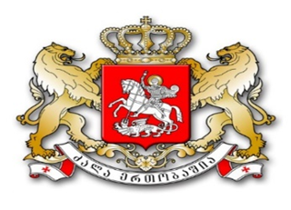
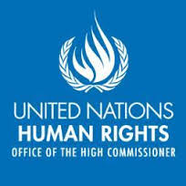 | 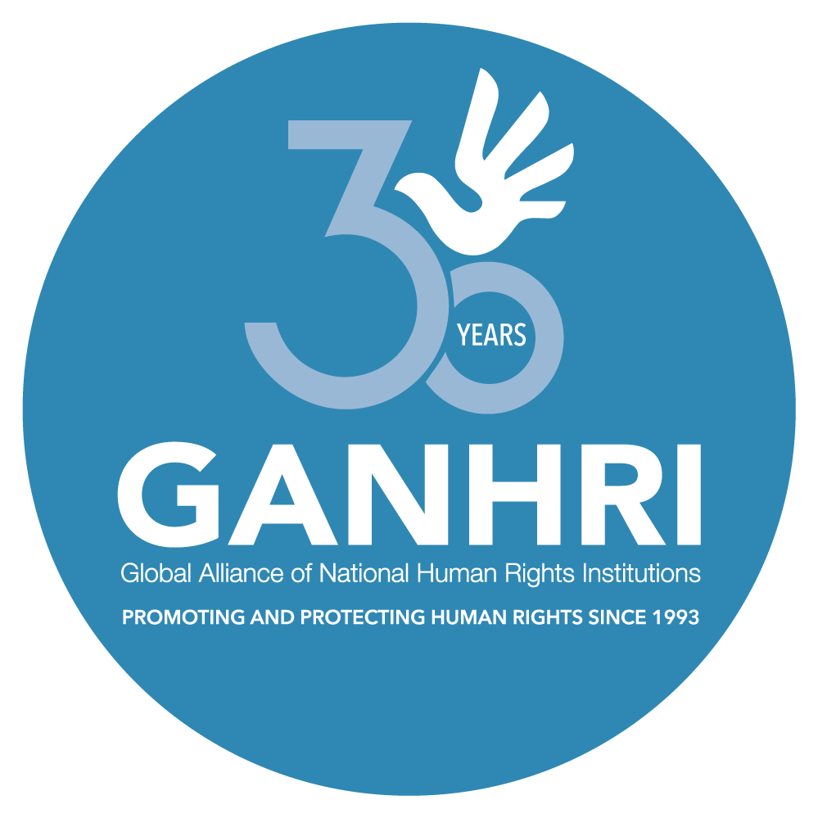 | 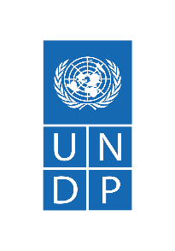

TriPartite Partnership to Support National Human Rights Institutions
Reporting Template

Instructions:
Narrative reporting on TPP support is due at the midpoint of implementation (no later than 28 June 2024) and one month following the end of the project implementation period using this template (no later than 31 January 2025). UNDP is responsible for completing this Reporting Template as well as updating the Result Framework that was approved alongside the project concept note (Annex I) in collaboration with OHCHR and the NHRI/national partner in situations of establishment.
Financial reporting on TPP support is also due at the midpoint of implementation (no later than 28 June 2024) and one month following the end of the project implementation period (no later than 31 January 2025). UNDP is responsible for completing the separate template provided in Excel (Annex II- Budget and Activity Tracker) in collaboration with OHCHR and the NHRI/national partner in situations of establishment as needed.
Please submit this completed Reporting Template, Result Framework (Annex I) and the Budget and Activity Tracker (Annex II) to chelsea.shelton@undp.org as Technical Secretariat for the TPP Management Committee. UNDP colleagues should also share the reporting documents with the relevant Regional Advisor on Human Rights.

Key information:
Project title: Advancing Environmental and Water-related Rights in Georgia
Country: Georgia
Please check one of the following to indicate the nature of the report:
☒ Mid-term report
☐ Final project report

UNDP focal point (name, title, email): Nino Jomarjidze, Human Rights Expert, nino.jomarjidze@undp.org
OHCHR focal point (name, title, email): Sopho Benashvili, Project Manager, sophio.benashvili@un.org
UNDP office finance focal point (name, title, email): Irina Mikeladze, Administrative and Financial Assistant, irina.mikeladze@undp.org
UNDP Resident Representative or Head of Office (name, title, email): Douglas Webb, Resident Representative, douglas.webb@undp.org
Total Budget: USD 50,000 Net Programmable
Start date of project: 1 January 2024
End date of project (up to 12 months): 31 December 2024
Please check one of the following (can only select one):
☐ This project is part of a larger umbrella programme or portfolio.
☐ This is a standalone project that has been or will soon be PAC-ed.
☒ This is a PIP which will pilot an approach that can be scaled up if implementation is successful.
☐ This is a PIP for foundational activities such as baseline assessments, stakeholder analysis and consultation, prodoc development.
☐ Other (please specify)

- About the TPP

To comprehensively support NHRIs, the United Nations Development Programme (UNDP), the United Nations Office of the High Commissioner for Human Rights (OHCHR) and the Global Alliance of National Human Rights Institutions (GANHRI), formed the TriPartite Partnership to Support National Human Rights Institutions (TPP) in 2011. The TPP increases efficiency and effectiveness of international support for NHRIs and leverages complementary mandates of each partner at global, regional, and country levels to provide high-quality and timely assistance to NHRIs that is jointly planned, delivered and evaluated through a rights-based approach to ensure maximum impact. The partnership is underwritten and operationalized by UNDP’s Global Programme on Strengthening the Rule of Law, Human Rights, Justice, and Security for Sustainable Peace and Development.

It is within this framework that Georgia was selected to receive joint TPP support in 2023-2024 to strengthen/assess the capacities of the Public Defender’s Office (PDO) of Georgia.

- Summary of report (est. ½ page)

- Provide a short summary of progress achieved during the project reporting period (mid-term or final project report). Further details to be provided in subsequent sections of this reporting template.
  - Highlight the key results and changes the project has achieved/enabled in supporting the NHRI in the protection and promotion of human rights.
  - Include contextual information in this summary by describing the socio-political and human rights environment that the project has operated within and any changes that have taken place in the context since the project was conceptualized. Analyze if the project has contributed to these changes, the implications of these changes on the projects’ outputs/outcomes, and how the project has adapted/ will adapt to the changes.
In 2024, Georgia experienced a continued decline in democratic and fundamental rights, as confirmed by international rankings. The country fell significantly in the World Press Freedom Index and the 2023 World Justice Project Rule of Law Index, and was assessed as a “semi-consolidated authoritarian regime”. Moreover, Georgia’s political dynamic and reshuffles in the political agenda have raised concerns about setbacks in democratic governance and human rights and increasingly questioned the government’s commitment to EU membership due to a rise in anti-Western rhetoric.
On 3 April 2024, the ruling party, Georgian Dream, re-introduced the draft law on the Transparency of Foreign Influence, mirroring the draft law the Georgian Parliament attempted to pass in 2023 but retracted after widespread protests. The law, adopted on May 3, 2024, requires nongovernmental organisations and media outlets that receive 20 percent or more of their annual revenue from abroad to register as “organisations carrying the interests of foreign power”. While authorities claimed the law was intended to enhance funding transparency, the law might impede the work of civil society organisations (CSOs) and media as core pillars of Georgian democracy and disrupt critical social services rendered by civil society. The reintroduction of this law has further strained relations between the Government and CSOs, leading over 200 CSOs to suspend all cooperation with state institutions.
The law prompted harsh criticism for its incompatibility with international human rights standards, including the rights to freedom of association and expression, the right to privacy, and the prohibition of discrimination by the PDO and international institutions, from the UN Country Team in Georgia, the UN Special Rapporteurs, the European Union (EU), the Venice Commission and the OSCE Office for Democratic Institutions and Human Rights (ODIHR). Since April 2024, the law has also sparked widespread demonstrations lasting for two months, marked by incidents of police violence during protest dispersals and reports of intimidation against human rights defenders and civil activists after the protests.
Given the PDO's constitutional mandate to supervise and uphold the protection of human rights, it has actively engaged in recent events to identify and respond to human rights violations, including by participating in parliamentary discussions of the law, monitoring demonstrations, visiting detainees in detention facilities and observing the trials of those detained.
Consequently, since the project was conceptualized, it has had to operate in a turbulent environment. Even though recent developments have not directly impacted the project’s outputs or outcomes, as there was no need to alter the planned activities, they have affected the implementation timeline since the PDO staff was actively involved in monitoring recent events. Despite these challenges, the project has bolstered the PDO’s monitoring functions in relation to the right to water through organisational capacity development.

- Impact and results (est. 2-3 pages)

- Outline the key results/progress achieved with TPP support by focusing on the impact of the activities supported (in bullet point form). Provide both qualitative and quantitative data for each of the results. Where possible, include sex-disaggregated data and links to relevant online materials e.g., resources developed, news articles, blogs, communication campaigns, etc.
- Explain how the results/progress achieved with TPP support have contributed towards outcome-level change, including the expected outcomes as outlined in the project concept note and results framework, including by linking project outputs to the SDGs, national development plans, regional priorities, the UNSDCF, etc. as well as any unexpected outcome.
- Describe in what ways the project has advanced gender equality and/or women’s empowerment and the impact the project has had on other groups at risk of being left behind (e.g., youth, persons with disabilities, indigenous peoples, displaced populations, etc.)
- Highlight any innovative tool, approach or practice that has been applied/ supported by the project. If so, describe the impact or results of this innovation and any forward-looking plans, i.e., are there indications that the innovation will be scaled-up and/or applied in other contexts?

Key results/progress achieved: As per the project concept note, the initial period of the project implementation was focused on bolstering the PDO’s monitoring functions in relation to the right to water. This support encompassed increasing the knowledge of the PDO staff on water-related rights, the creation of a monitoring methodology, and a questionnaire to enhance the PDO’s efforts in this domain. Hence, during the reporting period, the following results were achieved in this respect:
- Capacity of the PDO staff enhanced:
The PDO’s staff acquired necessary knowledge and capacity to effectively monitor the right to water in various regions through extensive in-person workshop held on 15-16 April 2024. Overall, 20 PDO staff members (6 men and 14 women) participated in the workshop. As the PDO plans to monitor the right to water in target regions following the finalization of the methodology and the questionnaire, special emphasis was placed on enhancing the capacity of regional staff. Consequently, 7 PDO staff members from various regions of Georgia attended the workshop. Participants positively evaluated the workshop, noting an increase in their knowledge of international standards on the right to water, monitoring methods, and the role of national human rights institutions (NHRIs) in monitoring environmental and water-related rights (annex 3).
- A monitoring system established:
Following the enhanced capacity from the workshop, the PDO started the development of a practical tool to ensure the sustainability of the learning and advance their mandate on water-related rights. In particular,
- Methodology: The draft monitoring methodology was developed which provides a structured approach for PDO staff to define the specific steps for conducting the monitoring of the right to water, ensuring consistent and effective monitoring practices.
- Questionnaire: A detailed questionnaire was elaborated which formulates tailored questions to identify specific issues during field visits, gather comprehensive data, and understand the challenges faced by communities in accessing water.
Contribution to Outcome-Level Change: As the project is in its early stage of implementation, it is premature to fully assess the extent to which the achieved results and progress have contributed to outcome-level change. However, based on the interventions already implemented some progress has been made to that end. Specifically, Outcome 1, which aims to enhance the PDO's monitoring capacity, advocacy, and community outreach regarding environmental and water-related rights has seen notable advancements in terms of bolstering the PDOs’ monitoring capacity. Hence, during the reporting period, progress was made towards achieving Output 1.1, contributing to the outcome-level change. As a result, the PDO is now well-equipped to better fulfil its constitutional mandate of protecting the right to water and conducting advocacy work in this area.
The progress achieved together with the expected Outputs and Outcome fully aligns with the Country’s key policy priorities, including Vision 2030-Development Strategy of Georgia and National Human Rights Strategy for 2022-2030.
The implemented and anticipated interventions also contributes to Outcome 1 of the United Nations Sustainable Development Cooperation Framework (UNSDCF) 2021-2025, which foresees that by 2025, “all people in Georgia enjoy improved good governance, more open, resilient, and accountable institutions, the rule of law, equal access to justice, human rights, and increased representation and participation of women in decision-making”. Through its work on environmental issues and the right to water, the project secondarily contributes to Outcome 5, which foresee that by 2025, “all people, without discrimination, enjoy enhanced resilience through improved environmental governance, climate action and sustainable management and use of natural resources in Georgia.”
The interventions further contributes to SDG 6 (Safe drinking water, sanitation and hygiene) by ensuring the availability and sustainable management of water and sanitation for all, as well as secondarily to SDG 5 (Gender equality) by promoting gender equality and SDG 16 (Peace, Justice, and Strong Institutions).
Women’s empowerment and the project’s impact on women and other groups at risk of being left behind: Vulnerable and marginalized groups are frequently overlooked in planning and governing water- and environmental-related initiatives. Therefore, their needs were prioritized and mainstreamed into the interventions during the reporting period.
- The workshop module specifically addressed the challenges faced by rights holders, including vulnerable and marginalized groups such as women, older persons, persons with disabilities, persons living in rural areas and highlands, internally displaced persons, and those living near the so-called administrative boundary line. The role of the PDO in monitoring how well these rights holders enjoy the right to water was also covered.
- Women staff of the PDO were empowered on issues related to the right to water. Specifically,14 women enhanced their knowledge through the workshop. This not only increased their expertise but also facilitated a better understanding of key environmental and water-related issues affecting women and girls.
- The draft monitoring methodology and the questionnaire, inter alia, encompass the methods for identifying problems faced by women and girls and other vulnerable and marginalized groups.
The needs of women and other groups at risk of being left behind will also be mainstreamed into the interventions planned for the second half of the project.

- Monitoring, evaluation, and learning (est. ½ page)

- Attach the completed Result Framework (Annex I) approved alongside the project concept note, demonstrating progress achieved during the reporting period (mid-term or final project report). Please note if there has been a change in project design and an indicator is no longer relevant.
- Provide a summary of the approach, methods (including tools, frameworks and processes), and activities that have been developed and/or implemented for the project, for monitoring, evaluation and learning. This may include but not limit to any surveys, studies, assessments, evaluations, field monitoring missions, reviews, etc. that have been developed and/or implemented.
- Describe any learning, reflection, and knowledge generation engagements and products that TPP project supported i.e., events, workshops, knowledge products, resources, etc. Include the relevant details to explain who led these engagements/ products and who benefited from them. Where possible, provide sex-disaggregated data for the number of participants and quantitative metrics for engagement, e.g., number of downloads etc.
- Attach any knowledge products / resources developed or link to them online if publicly available.

Monitoring and evaluation: To ensure effective planning, preparation, implementation, and monitoring, regular meetings were institutionalised between UNDP, OHCHR and the PDO. These meetings facilitated the coordination and coherence of project activities. During the meetings, relevant issues related to specific interventions were discussed, and the next steps were agreed upon. Post-workshop, TPP partners continued dialogue to assess further support needs for developing a comprehensive methodology system for monitoring environmental and water-related issues. This ongoing dialogue highlights the commitment to continuous learning and adaptation to enhance the project's impact.
Learning: During the reporting period, the project supported the following engagements and products aimed at learning, reflection, and knowledge generation:
- Workshop on Environmental and Water-Related Rights: The workshop, conducted on April 15-16, 2024, served as a significant learning event, enhancing the knowledge and skills of PDO staff in monitoring environmental and water-related rights. A total of 20 staff members (14 women, 6 men), including regional representatives and two PDO deputies, benefitted from this workshop. Amanda Loeffen, an experienced expert in water, energy, and sustainable development and CEO of “Human Right 2 Water,” led the workshop. Representatives from UNDP, OHCHR and the EU-funded "Support to the Office of the Public Defender of Georgia" were also present. The workshop was designed to provide a deep understanding of international standards on the right to water, monitoring methods, and the role of NHRIs in monitoring environmental and water-related rights (annex 3).
- Knowledge Products: The project produced a draft methodology and questionnaire, which will be instrumental for PDO staff to closely monitor the situation regarding the right to water in targeted regions. These tools were developed through a collaborative process involving UNDP, OHCHR, and the PDO, ensuring they meet the specific needs of the PDO’s monitoring activities (the documents will be submitted together with the final report).
Completed Annex I Result Framework is also attached to the mid-term report.

- Budget and activities

- Attach the completed Budget and Activity Tracker (Annex II) approved alongside the project concept note, outlining the budget allocated, expenditure, and unspent funds (if any) for each activity.
- Note that if there are unspent funds at the end of the authorized period for expenditure a return to donor process may be initiated.

Detailed information on the budget is provided in Annex II Budget and Activities Tracker.
A total of 4,500 USD was allocated for training for the PDO staff on the right to water. Since the workshop was conducted in partnership with the EU-funded project, there were savings of 333 USD. The remaining funds will be utilised during the remaining period for implementation of other activities.
Additionally, 600 USD and 1,200 USD were allocated for developing a monitoring methodology on the right to water and a questionnaire to identify challenges related to this right, respectively. However, due to the reasons outlined above, the finalization of these documents was delayed, and the allocated funds were not utilised during the authorised period for expenditure. These documents are currently in the process of development, and the allocated funds will be utilized once they are finalised.

- Partnerships (est. 1 page)

- Describe how TPP partners have collaborated in support of the NHRI during implementation of the project and any plans to continue collaboration beyond project closure.
- Explain how other key partners and stakeholders (UN entities, civil society, private sector, other NHRIs etc.) have been engaged in project activities.
  - Highlight any South-South exchanges or opportunities for peer support that was facilitated by the project.
- Note any challenges and opportunities for further partnership building in support of the NHRI.

TPP partners have a long-enduring experience in jointly supporting the PDO in exercising its pivotal constitutional mandate of monitoring and upholding human rights in Georgia. As noted above, all project activities were designed and implemented with equal and meaningful participation of TPP partners, facilitating a more comprehensive response and allowing for the collective driving of project activities.
UNDP and OHCHR are in the process of developing the project proposal for the third phase of the joint project “Human Rights for All”, within which the results of the current initiative will serve as the foundation for subsequent interventions to enhance further the institutional and capacity development of the PDO on the environmental and water-related rights, hence, ensuring the continuous collaboration beyond the project’s lifespan.
Additionally, the project teamed up with external stakeholders, to enrich the project impact. In particular,
- Leveraging international experience and networks: After jointly developing ToR, the TPP partners conducted scoping to identify a highly qualified expert for developing the workshop module for PDO personnel, harnessing their established networks and partnerships. UNDP leveraged its contacts and through its regional hub, which assisted the project team in identifying a highly skilled water-right-related international expert who brought extensive experience and methodological knowledge for increasing capacities of the PDO personnel on water and environmental-related rights.
- Establishing synergies and optimizing resources: Given the project’s resource constraints and the commitment to ensure a long-lasting impact, the project team partnered with the EU-funded project "Support to the PDO" to scale up the workshop for PDO staff on monitoring water and environmental rights. Through expert and financial collaboration of the EU-funded project, in-person workshop enriched the engagement and experience-sharing between the international expert and the PDO personnel. This synergistic approach with the EU-funded project transcends project timelines, further supporting the scale-up of project initiatives and PDO advocacy addressed on water and environmental rights. Additionally, this process cultivated a partnership between the non-profit organization “Human Right 2 Water” represented by the international expert and PDO, paving the way for continuous expertise and knowledge-sharing on systemic and policy work on the right to water prioritizing the most vulnerable and marginalized.
Although CSOs, grassroot movements, activists, and other stakeholders have not been extensively engaged in the activities implemented during the reporting period due to the nature of the delivered activities, upcoming endeavours will pivot towards harnessing these partnerships, including with the local self-governments. This will facilitate broad and representative engagement and further incentivize collaboration with the PDO on addressing the challenges related to water and environmental related rights.

- Good practices and lessons learned (est. 1 page)

- Share good practices that have emerged from the project and how they have contributed to the project’s success.
- Describe any challenges faced during implementation and how they were/are being navigated to achieve the projects objectives.
- Document lessons learned that can inform future TPP support. Reflect upon the key factors that have contributed to the project’s success or challenges encountered.
- Note any support needed from TPP management at the global level.

While the TPP initiative is still in its early stages of implementation, it is premature to fully assess the good practices, challenges, and lessons learned. However, preliminary considerations and reflections can be made:
Operational challenges were encountered during the reporting period, in particular:
- Human resource issue: According to the initial plan, the workshop was scheduled to take place before March 2024. However, conducting the workshop proved challenging due to difficulties in identifying an expert with sufficient expertise to lead the workshop. To address this, UNDP leveraged its contacts and, through its regional hub, requested peer support from the Water Team, which assisted in sharing their experience and identifying an expert to develop the module and deliver it to the PDO staff.
- Logistical change in the workshop: Despite initially planning for an online format, the PDO requested an in-person workshop to ensure effectiveness and facilitate live exchanges between experts and participants. Given the TPP project’s resource constraints, through generous support of the EU-funded project, in-person workshop was conducted.
During the reporting period, contextual challenges also emerged. Notably, since the project's inception, it has navigated in a turbulent environment, characterized by escalating difficulties in upholding human rights. Given the pivotal role and mandate of the PDO, it has actively engaged to identify and address human rights violations.
The operational and contextual challenges led to some delays in the project implementation timeline. Nonetheless, effective coordination between UNDP, OHCHR and the PDO and with partners helped mitigate these risks, allowing the challenges to navigate smoothly to achieve the project’s objectives.

- Way forward (est. ½ page)

For mid-term report:
- Describe the implementation plan for the rest of the project including the tentative timelines for key activities.
- Describe any specific challenges or risks that have arisen that may affect project implementation. Provide justification for any changes needed to the original project proposal (scope or timing) for approval from TPP and UNDP’s Global Programme management.
- Explain what actions will be taken to ensure sustainability of results beyond project closure.

For final project report:
- Describe how results from the project will be built upon and follow up efforts be integrated into existing support structures for the NHRI or if new mechanisms have been created to sustain results, i.e., Sustainability Plan and the use of complementary funding streams.
- Explain how the catalytic potential of the project outputs will be leveraged for greater impact beyond the project period or scope, e.g., as a foundation for further resource mobilization for the NHRI, as an established partnership to support the NHRI, as a mechanism to ensure rights-based implementation, as a precedent for further reforms etc.
- Note any resource and capacity needs identified and any national/partner commitment secured.

Implementation plan
Key Activity | Original timeline | Tentative timeline
Finalize a monitoring methodology and a questionnaire on the right to water | 30/04/2024 | 10/07/2024
Field visits to identify the local community challenges (particularly for older people and women) related to the right to water | 30/07/2024 | 10/09/2024
Meeting with the target local governments representatives | 30/07/2024 | 10/09/2024
Meeting with local civil society organisations and grassroot movements | 30/07/2024 | 10/09/2024
Prepare the special report on access to water | 30/10/2024 | 30/10/2024
Workshop with the local government representatives for discussing the preliminary monitoring findings and recommendations | 30/10/2024 | 30/11/2024
Present the special report on access to water, with involvement of relevant duty bearers and civil society organisations | 30/10/2024 | 30/11/2024
Awareness raising meetings with school children in the regions on environmental and water-related rights and the PDO’s mandate | 30/11/2024 | 30/11/2024
Awareness raising meetings with students on the environmental and water-related rights and available remedies | 30/11/2024 | 30/11/2024
Awareness raising meeting with local community representatives on the right to clean environment and right to safe water, with particular emphasis on disadvantaged groups, including women, elder, ethnic minorities, IDPs | 30/11/2024 | 30/11/2024
Create multimedia products (including, video, posters, information cards) on environmental and water-related rights | 30/12/2024 | 30/12/2024
Specific challenges and risks: Upcoming Parliamentary elections in October 2024 coupled with the increasingly difficult time being experienced in Georgia with regards to realisation of human rights might impede the timely implementation of the TPP project initiatives. The TPP partners will leverage enduring and strong partnerships with the government institutions at local and central levels to ensure smooth implementation of the programme activities. In view of that, there is no need of any changes in the project scope. However, considering the above-noted, slight changes are needed to the original project proposal in terms of timing of the implementation of the activities, hence, approval from TPP and UNDP’s Global Programme management for the timing adjustments proposed above in the relevant table is sought to ensure the successful realization of the project goals. The extended timeline will give the TPP partners possibility to better coordinate with government institutions, civil society and local communities and mitigate risks associated with the elections and the current human rights situation, ensuring a smooth implementation process.
Sustainability of results beyond project closure: The TPP partners are employing several strategies to promote sustainable and catalytic impact beyond project closure:
- The enhanced capacity on the environmental and water-related rights will enable the PDO to better fulfil its mandate on protecting these rights beyond the project cycle. While initially, the monitoring would be conducted in several regions, this work and used methodology can be replicated and scaled up across Georgia in the future. The monitoring findings on the right to water can also feed into the PDO's advocacy work, including through presenting specific recommendations within the parliamentary reports beyond the project lifespan.
- Bolstering awareness about environmental and water-related rights and building networks with local communities will contribute to public trust-building in the PDO and empower people to report and speak up about systemic violations that often go unreported. The awareness will also give the platform to disadvantaged groups to advocate for their rights through the PDO’s mandate, thus catalysing broader advancements in the human rights system.

- Added value of TPP support (est. ½ page)

- Reflect on the added value of the TPP support delivered through a partnership approach in the country context that led to the achievement of the results outlined above e.g., strengthened partnerships in support of the NHRI, reducing the burden on the NHRI to coordinate support from international partners, injecting resources to fill a key gap, catalyzing further impact, etc.
- Share recommendations on what could be done to enhance the added value of TPP support in the future and any suggestions for TPP management at the global level.
- Provide a few testimonials/quotes from key partners on the impact of the TPP support.

In the context of Georgia, the TPP support delivered through a partnership approach brings significant value-add by leveraging the collective expertise, comparative advantages, and resources of UNDP, OHCHR, and the PDO to address pressing issues related to environmental and water-related rights. In particular:
Reduced Coordination Burden: The TPP partnership approach has alleviated the coordination burden on the PDO. As a result, the PDO benefits from a streamlined and cohesive support system allowing to focus more on its core functions rather than administrative coordination and operational/technical issues.
Strengthened Partnerships in Support of the PDO: As noted above, the collaboration among TPP partners has reinforced the network of support for the PDO.
Resource Injection to Address Key Gaps: Water-related issues remain mostly unaddressed in Georgia and there has not been a comprehensive study to explore the facets of the right to water and examine the challenges faced by the local population in accessing water. In addition, the expertise and resources of the PDO to properly track the implementation of the international standards and national legislation, including through international support, are scarce. Hence, through this partnership, the TPP has injected critical resources into areas that were previously underfunded or overlooked. This targeted resource allocation enables the PDO to address key gaps, particularly in advancing environmental and water-related rights in Georgia.
Enhanced Advocacy and Monitoring: The collaborative efforts will bolster the PDO’s capacity to conduct comprehensive monitoring and advocacy on environmental and water-related rights. With the support of TPP partners, the PDO is well-equipped to effectively present findings and recommendations in annual and special reports on water-related rights.

- Photos

- Attach high-resolution photos (at least 300 dpi) related to the TPP support/ project goals.
  - Provide caption and credit information for each photo.
- Note that the photos will be used for reporting and communications purposes by TPP partners including UNDP, OHCHR, and GANHRI.

Photo 1. Participants at the PDO workshop held on 15-16 April on the right to water, engaged in discussions about enhancing the implementation and enforcement of water-related rights in Georgia.
Photo credit: the PDO of Georgia.
Photo 2. Trainers at the PDO workshop held on 15-16 April on the right to water, leading sessions to enhance understanding and implementation of water-related rights in Georgia.
Photo credit: the PDO of Georgia.

In situations where an NHRI has not yet been established, please replace “NHRI” with national partner(s) throughout this template.
http://humanright2water.org/vision-mission-and-values/

